Homer Middle School

Activity Night Permission Slip

____________________________ has my permission to attend the Homer Middle School Activity Night on Friday, October 14, from 6:30 – 8:30pm. I will make arrangements to transport my student home promptly at 8:30pm. Only current 7th and 8th grade students enrolled at Homer Middle School will be admitted.

The following activities will be available:
Dance in half the gym
Open gym in half the gym
Dodgeball game in MPR
Ping pong and foosball in hallways
Wii/Karaoke in the library

___________________ ______________________________ _________________
Parent name (print) Parent signature Phone # for the evening
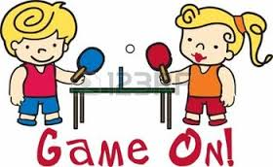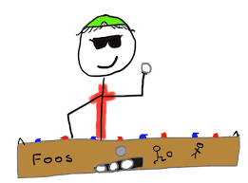

Students:
Any HMS student who does not have an outstanding detention or suspension is invited to attend the activity night. Students must be in class and on time the day of the activity.

In order to participate in this activity night, I agree to the following:

1. To display appropriate behavior at all times.
2. To follow all school rules and dress code with the following exceptions: Hats are permitted. Shoulders may be shown; although, strapless tops are not permitted. Skirt and shorts length shall follow school dress code. Cell phones, cameras, and Ipods are permitted, but must be used responsibly and respectfully.
3. To show respect to all adult chaperones.
4. To remain inside the building until the conclusion of the activity.
5. To participate in the activities stated above.

Students who violate any of the above conditions will be sent home.

____________________________________________________________
Student signature

- Students must present this signed permission slip to be admitted to the activity night.
- A $2.00 admission fee is requested.
- The snack shack will be selling pizza slices and drinks.
- No students will be allowed to enter the Activity Night before 6:30 or after 7:30 P.M.
- A student who leaves the premises will not be readmitted. Students must be picked up promptly at 8:30 P.M.

